**PCS151 List of Programs for practice**

# Write a program to print the value and size of different data types (Use size of operator).

# **Write a program to find the addition, subtraction, multiplication, division of two numbers**

1. Write a program to calculate Simple and Compound Interest.
2. Write a program to calculate total salary based upon the following:-

HRA = 3 % of Basic salary, TA = 5 % of Basic salary, DA = 3 % of Basic salary

1. Program to convert temperature from Celsius to Fahrenheit
2. Program to enter an ASCII code and display the character associated with it
3. Program to determine the value of a variable num2 depending on num1
4. Write a C Program to swap two numbers (integers) using third variable
5. Program to find the area of a circle and rectangle
6. Write a C Program to swap two numbers (integers) without using third variable
7. Write a program to input 3 sides of triangle and calculate area.
8. Program to show similarity between int and char
9. Write a C program code to swap using bit wise XOR
10. Program to show the effect of increment/decrement operator
11. Program to show working of arithmetic operators; also implement implicit and explicit
12. Program to show working of unary Post/Pre Increment/Decrement operator
13. Write a C program which takes no of days as input and convert it into no. of year, month, week, and days
14. Write a C program to find whether a given number is positive, negative, or zero.
15. Write a C program to print greater.
16. Program to find the largest of three numbers
17. Write a C program to find the largest of three numbers.
18. Program to find the largest of three numbers using Logical AND (&&)
19. Write a program to find the simple interest if principle amount is less than 10000 else find the compound interest
20. Program to check and print days of week
21. Write a C program to check whether input alphabet is a vowel or not
22. Program to calculate the net salary of a person
23. Write a C program to find roots of a quadratic equation. Find roots only when discriminant is positive.
24. Write a C program to find whether entered character is small case, capital case, a digit or a special symbol.
25. Write a C program to calculate bill for Uttarakhand state electricity board.
26. Write a C program to find grade of the student for four subjects marks for each subject to be entered by the user. Calculate percentage and based upon the condition print the grade.
27. Write a C program to check whether entered year is leap year or not
28. Write a C program to calculate the bill for a shopkeeper who sales mango @ 5 RS per mango.If bill is greater than 500 then give discount of 10% otherwise no discount.
29. Write a C program to input three side of a triangle and then calculate area.(Applying proper validations)
30. Program to illustrate the working of a simple calculator
31. Write a 'C' program to compute y as a function of x according to the formula

y = 1.2x + 0.98 when x <= 1.0

y = 1.7x + 0.09 when x > 1.0

You must use the switch statement.

1. Write a C program to check whether input alphabet is a vowel or not (Using switch)
2. Write a C program to print first n numbers.
3. Write a C program to find the sum of first n numbers using for loop.
4. Write a C program to print first 100 numbers. Write a C program to find sum and average of first n natural numbers using while loop.
5. Program to display even numbers between1-20
6. Write a C program to find and print factorial of a number
7. Program to display odd numbers between1 and n (where n is inputted by user)
8. Write a c program to find out NCR factor of given
9. Write a C program to print square of n numbers, where value of n is inputted by the user.
10. Write a C program to find the sum of even and odd numbers between x and y.
11. Write a C program to add digits of a number
12. Write a C program to reverse a number
13. Write a C program to find Armstrong number
14. Write a C program to find Palindrome Numbers
15. Write a C program to print entered number in words.
16. Write a c program to check whether a number is strong or not
17. Write a C program to print n terms of Fibonacci series
18. Write a program to generate the Fibonacci series in c using for loop
19. Write a C program to find sum of n terms of Fibonacci series
20. Write a C program to find the sum of the following series:

1+3+5+7+............ upto n terms

1. Write a C program to find the sum of the following series:

1/1!+2/2!+3/3!+4/4!+............ upto n terms

1. Write a C program to find the sum of the following series:

1/1!+3/2!+5/3!+7/4!+............ upto n terms

1. Write a C program to find the sum of the following series:

12/1!+22/2!+32/3!+42/4!+............ upto n terms

1. Write a C program to find the sum of the following series:

1!+2!+3!+4!+............ upto n terms

1. Write a C program to find the sum of the following series:

1/1!+22/2!+33/3!+44/4!+............ up to n terms

1. Write a C program to find the sum of the following series:

1+1/2+1/3+1/4+.............. upto n terms

1. Write a C program to draw following pattern

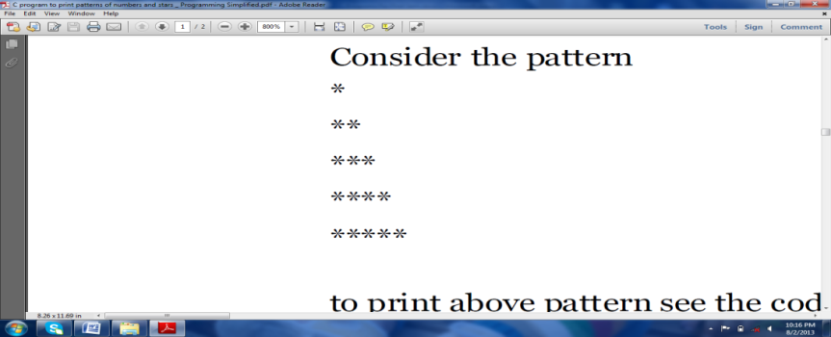

1. Write a C program to draw following pattern

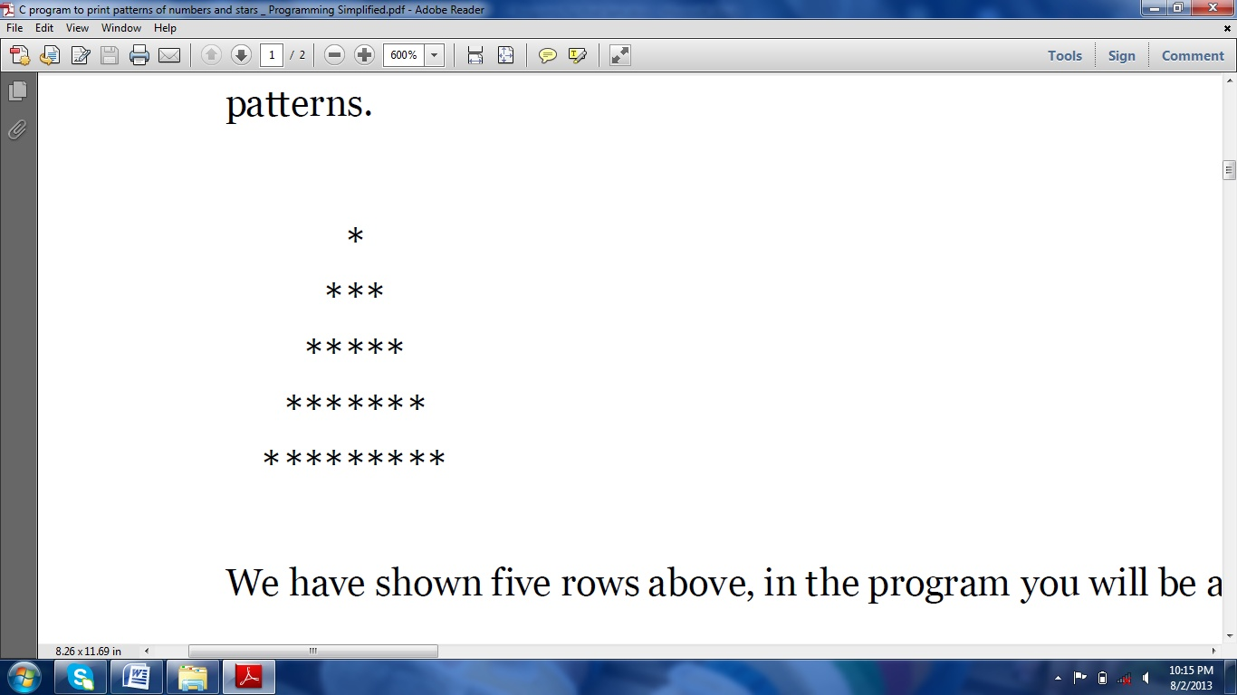

1. Write a C program print the following pattern according to number of rows entered (Use While)

****

***

**

*

1. Write a C program to draw following pattern

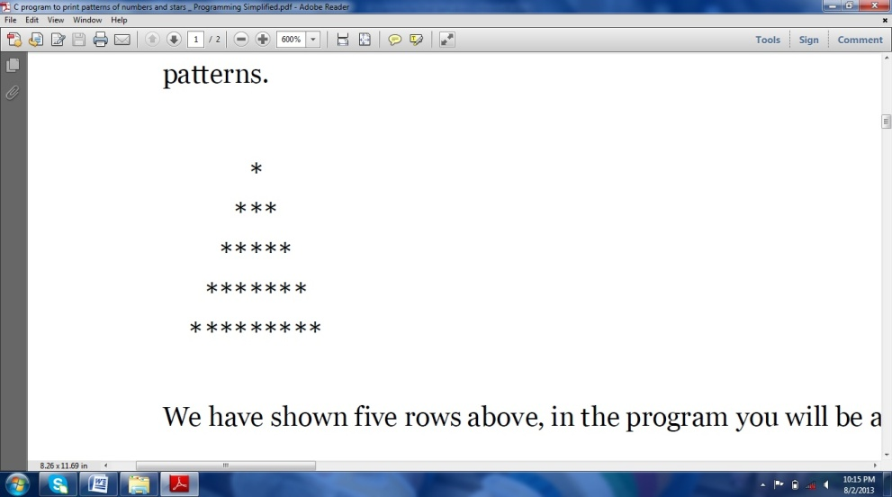

1. Draw Fibonacci Pattern

*

*

**

***

*****

********

*************

1. Write a C program to draw following pattern

3

33

333

3333

33333

1. Write a C program to draw following pattern

Note: No nested loop is required.

1, 11, 121 ….are single numbers so it should be printed at once.

1

11

121

1331

14641

1. Write a C program which calculate and print sum and average of elements of an array
2. Write a C program to convert a decimal number to binary number using array(number should be a whole number)
3. Write a C Program to print the elements of array in reverse order
4. Write a C Program to store the elements of array into another array in reverse order
5. Write a C program to print elements of an array greater than average
6. Write a c program to perform sorting on 1-D array
7. Write a c Program to search an element in a 1D array
8. Write a c program to find maximum and minimum element in 1-D array Write a C program to insert an element at particular position of an array
9. Write a c program to find maximum and minimum element in 1-D array by sorting technique
10. Write a c Program to add two 1d array of unequal sizes
11. Write a C Program to print the upper and lower triangle in a matrix
12. Write a c Program to find addition of two 2d array
13. Write a C Program to read two matrices A & B and perform addition. After Addition perform transpose on final matrix and print the result in matrix form
14. Write a C Program to find sum of both diagonals elements of a given matrix. Also find row sum & column sum (Should work on square and non square matrix)
15. **WACP to sort array in ascending order and print smallest, second smallest, largest and second largest element**
16. **Write a C Program to find the maximum, minimum, second maximum and second minimum element of an array and print their index**
17. **Write a C Program to add the elements of both diagonals of a user defined matrix**